**On the structural origins of ferroelectricity in HfO2 thin films**

[Xiahan Sang](http://aip.scitation.org/author/Sang%2C+Xiahan), [Everett D. Grimley](http://aip.scitation.org/author/Grimley%2C+Everett+D), [Tony Schenk](http://aip.scitation.org/author/Schenk%2C+Tony), [Uwe Schroeder](http://aip.scitation.org/author/Schroeder%2C+Uwe), and [James M. LeBeau](http://aip.scitation.org/author/LeBeau%2C+James+M)

Citation: Appl. Phys. Lett.**106**, 162905 (2015); doi: 10.1063/1.4919135

View online: <https://doi.org/10.1063/1.4919135>

View Table of Contents: <http://aip.scitation.org/toc/apl/106/16>

Published by the [American Institute of Physics](http://aip.scitation.org/publisher/)

**Articles you may be interested in**

[Ferroelectricity in hafnium oxide thin films](http://aip.scitation.org/doi/abs/10.1063/1.3634052)   
[Applied Physics Letters](http://aip.scitation.org/doi/abs/10.1063/1.3634052) **[99](http://aip.scitation.org/doi/abs/10.1063/1.3634052)**[, 102903 (2011](http://aip.scitation.org/doi/abs/10.1063/1.3634052)); 10.1063/1.3634052

[Stabilizing the ferroelectric phase in doped hafnium oxide](http://aip.scitation.org/doi/abs/10.1063/1.4927805)   
[Journal of Applied Physics](http://aip.scitation.org/doi/abs/10.1063/1.4927805) **[118](http://aip.scitation.org/doi/abs/10.1063/1.4927805)**[, 072006 (2015); 10.1063/](http://aip.scitation.org/doi/abs/10.1063/1.4927805)1.4927805

[Ferroelectricity in undoped hafnium oxide](http://aip.scitation.org/doi/abs/10.1063/1.4922272)   
[Applied Physics Letters](http://aip.scitation.org/doi/abs/10.1063/1.4922272) **[106](http://aip.scitation.org/doi/abs/10.1063/1.4922272)**[, 232905 (201](http://aip.scitation.org/doi/abs/10.1063/1.4922272)5); 10.1063/1.4922272

[The origin of ferroelectricity in Hf1-xZrxO2: A computational investigation and a surface energy model](http://aip.scitation.org/doi/abs/10.1063/1.4916707) Journal of Applied Physics **117**, 134109 (2015); 10.1063/1.4916707

[Enhancing ferroelectricity in dopant-free hafnium oxide](http://aip.scitation.org/doi/abs/10.1063/1.4973928)   
[Applied Physics Letters](http://aip.scitation.org/doi/abs/10.1063/1.4973928) **[110](http://aip.scitation.org/doi/abs/10.1063/1.4973928)**[, 022903 (2017); 10.1063/1](http://aip.scitation.org/doi/abs/10.1063/1.4973928).4973928

[Evolution of phases and ferroelectric properties of thin Hf0.5Zr0.5O2 films according to the thickness and annealing temperature](http://aip.scitation.org/doi/abs/10.1063/1.4811483)   
[Applied Physics Letter](http://aip.scitation.org/doi/abs/10.1063/1.4811483)s **102**, 242905 (2013); 10.1063/1.4811483



APPLIED PHYSICS LETTERS 106, 162905 (2015) 

[On the structural origins of ferroelectricity in HfO2 thin films](http://dx.doi.org/10.1063/1.4919135)

Xiahan Sang,1Everett D. Grimley,1Tony Schenk,2Uwe Schroeder,2and James M. LeBeau1 1Department of Materials Science and Engineering, North Carolina State University, Raleigh,   
North Carolina 27695-7907, USA   
2NaMLab gGmbH/TU Dresden, Noethnitzer Str. 64, Dresden D-01187, Germany

(Received 24 February 2015; accepted 16 April 2015; published online 23 April 2015)

Here, we present a structural study on the origin of ferroelectricity in Gd doped HfO2 thin films. We apply aberration corrected high-angle annular dark-field scanning transmission electron microscopy to directly determine the underlying lattice type using projected atom positions and measured lattice parameters. Furthermore, we apply nanoscale electron diffraction methods to visualize the crystal symmetry elements. Combined, the experimental results provide unambiguous evidence for the existence of a non-centrosymmetric orthorhombic phase that can support spontaneous polarization, resolving the origin of ferroelectricity in HfO2 thin films. V C 2015 AIP Publishing LLC. [<http://dx.doi.org/10.1063/1.4919135>]

Recent studies have demonstrated the emergence of ferroelectricity in HfO2 thin films doped with elements including Si,1Y,1and Al,2among others.3Combined with controlled doping, the response is further influenced by dimensional confinement introduced through capping layers including TiN,1TaN,4RuO2,5Pt,5,6or Ir.7–9While these HfO2 thin film structures show promise as candidates for non-volatile memory applications,10direct identification of the phase responsible for spontaneous polarization has remained experimentally elusive.

At atmospheric temperature and pressure, bulk HfO2 adopts a monoclinic structure with space group P21/c. The structure is centrosymmetric and hence does not support spontaneous polarization necessary for a true ferroelectric response. When doped and confined, however, HfO2 thin films have been proposed to undergo a transition to a non-centrosymmetric orthorhombic structure.10,11This has been claimed based on a comparison of HfO2 to the related ZrO2,

patterns is complicated due to the mixture of different phases in the film, similarities between the respective reference pat-terns of the potential HfO2 phases, and severe peak broaden-ing of polycrystalline thin films, as shown in Figure 1(b). Moreover, the Pmn21 phase has also been proposed as a candidate following a search for low-energy phases using density functional theory (DFT).15   
 In this letter, we explore the structural origins of ferroe-lectricity in HfO2 films using aberration corrected scanning transmission electron microscopy (STEM). We apply high-angle annular dark-field (HAADF) STEM imaging to directly observe and quantify the film structure along a vari-ety of crystallographic directions. Complementing imaging, we use position averaged convergent beam electron diffrac-tion (PACBED) to determine the projected symmetry and polarity at the nanoscale.20Through the combination of these techniques, we report direct experimental evidence for the presence of the polar orthorhombic Pca21 phase in Gd doped

|  |  |
| --- | --- |
| which shares many phase similarities with HfO2 including | HfO2 thin films. |

the transition from cubic to tetragonal to monoclinic as tem-perature decreases.12Specifically, there are four proposed orthorhombic HfO2 phases adopting the space groups Pmn21, Pca21, Pbca, and Pbcm.4,13–17Of these phases, only Pca21 and Pmn21 are non-centrosymmetric.15   
 For comparison, Figure 1(a) shows each of the afore-mentioned phases projected along the four major zone axes ½100�; ½010�; ½001�, and ½110�. The four Hf atoms form a dis-torted face centered lattice with the eight O atoms occupying the pseudo-tetrahedral interstitial sites. Close inspection of Pca21 and Pmn21 phases reveals that oxygen atoms shift along the c axis thereby allowing spontaneous polarization. Here, we focus on the lower symmetry phases of HfO2, i.e., monoclinic and orthorhombic, as the two higher symmetry phases Fm�3m and P42nmc are paraelectric.1,18,19   
 Due to consistencies with the related ZrO2 system, the Pca21 orthorhombic structure is primarily thought to be the cause of ferroelectricity in HfO2, but this has not been unam-biguously confirmed by experiment.10While grazing inci-dence x-ray diffraction (GIXRD) experiments point to the existence of an orthorhombic phase, the analysis of the

Metal-insulator-metal capacitor structures were fabri-cated as described in Ref. 4. In the present work, the Gd doped HfO2 thin film with a thickness of 27 nm was annealed at 650�C for 20 s. Polarization (triangular field sweep, 10 kHz) and small-signal capacitance (triangular bias field sweep, 10 Hz; 150 mV small-signal amplitude, 10 kHz) were measured using a TF Analyzer 3000 by aixACCT Systems. TEM samples were prepared from Gd:HfO2 capacitors using focused ion beam (FEI Helios nanolab 600i dual beam sys-tem). HAADF-STEM and PACBED were acquired using a probe-corrected FEI Titan G2 60–300 kV operated at 200 kV with a beam current of approximately 70 to 100 pA. The collection inner semi-angle and probe semi-convergence angle were approximately 77 mrad and 14 mrad or 20 mrad, respectively. Images were acquired and processed with the revolving STEM (RevSTEM) method (details provided in Ref. 21). Each RevSTEM dataset contained 20 image frames of size 1024 � 1024 pixels with a 90�rotation between each successive frame. Atom column positions in each RevSTEM image were then determined by fitting each atom column to a two-dimensional Gaussian function and then

|  |  |  |
| --- | --- | --- |
| 0003-6951/2015/106(16)/162905/4/$30.00 | 106, 162905-1 | V C 2015 AIP Publishing LLC |

|  |  |  |
| --- | --- | --- |
| 162905-2 | Sang et al. | Appl. Phys. Lett. 106, 162905 (2015) |

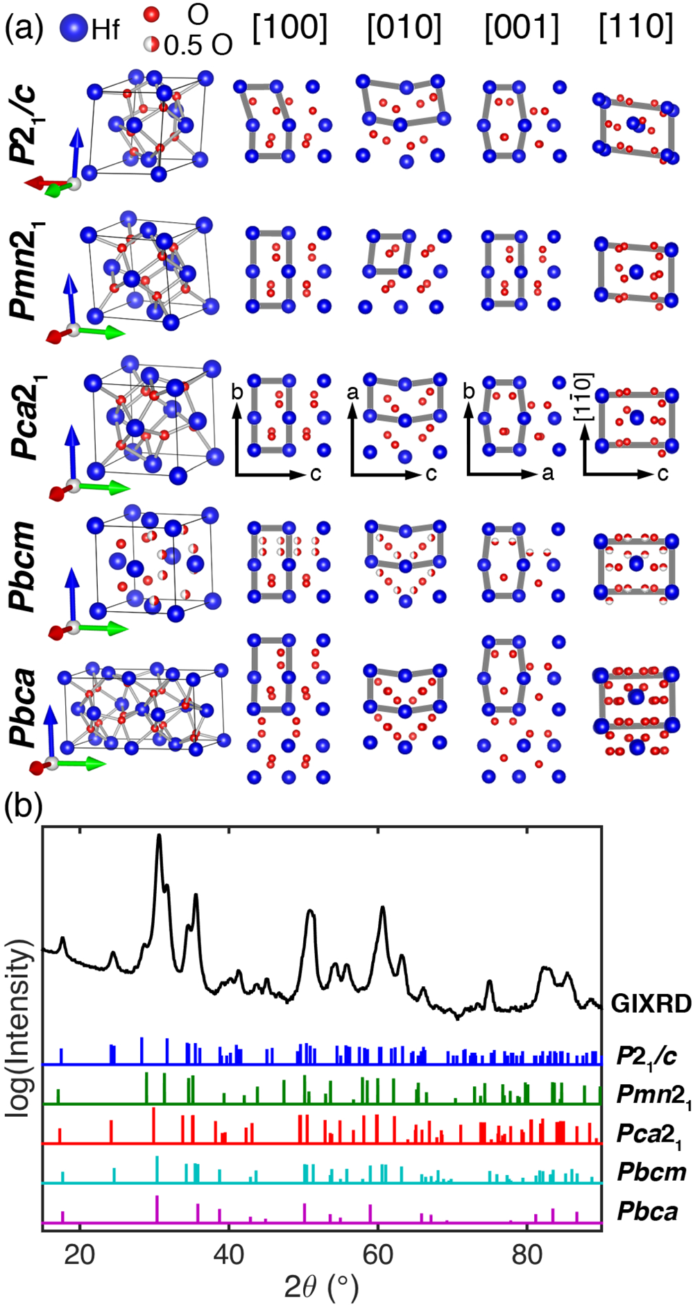

FIG. 1. (a) The crystal structure of five HfO2 phases projected along four major zone axes. The space group settings and the lattice vectors (a is red, b is green, and c is blue) have been selected to yield similar atom column arrangement along common axes with details provided in the footnotes of Table I. (b) GIXRD patterns from experiment compared to powder diffrac-tion file data for the five phases.

mapped into a matrix representation.22Lattice constants were measured directly from the distance between atom col-umn locations in real-space.23PACBED diffraction patterns were simulated with the dynamical diffraction simulator MBFIT (Many-Beam dynamical-simulations and least-squares FITting).24The PACBED method was selected as it enables acquisition of the CBED pattern from a selected nanometer range area, providing high spatial resolution and also high sensitivity to the local polarity.20,25   
 Similar to the findings in the original work by B€oscke et al.,10a characteristic hysteretic behavior of both polariza-tion, P, and relative permittivity, k, as a function of the elec-tric field, E, were obtained, as displayed in Figure 2. The purely dielectric k-value (not affected by an enhancement around the switching fields of the ferroelectric) is between

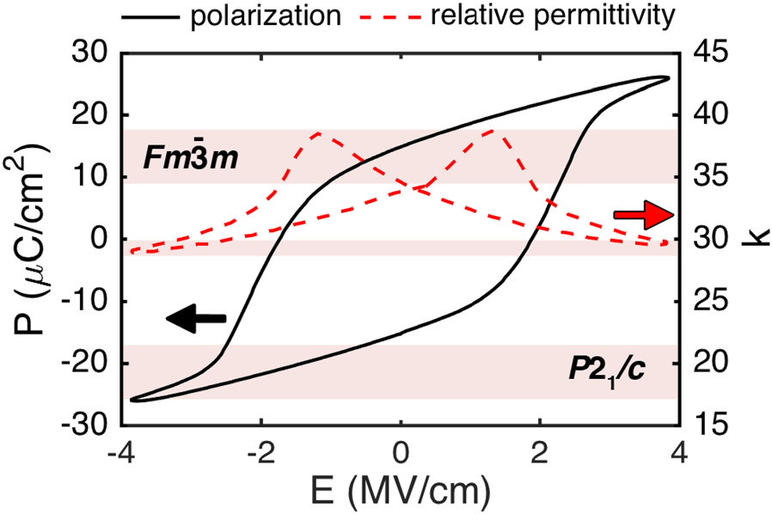

FIG. 2. (black, solid line) Typical hysteresis obtained from polarization and small-signal-capacitance measurements for the Gd:HfO2 sample. (red dashed line) Relative permittivity as a function of applied field accompanied by ranges for the monoclinic and orthorhombic phases.

what would be expected for a low-symmetry monoclinic P21/c (Refs. 18 and 19) and a high-symmetry cubic Fm�3m phase.1,18,19Close examination of the structures in Figure 1 reveals that the reference structures share both common and distinct features (highlighted in each projection by gray boxes). In the case of the monoclinic structure, only the ½001� is comparable with the orthorhombic structures. For polar phases, Pmn21 and Pca21, the projected Hf arrange-ments are significantly different in all projections except ½100�. We also notice that the other three orthorhombic phases Pca21, Pbcm, and Pbca exhibit very similar arrange-ment of Hf atom columns along all four zone axes with only difference in O atom column arrangement. Thus, the highlighted features in Figure 1 enable the lattice type to be directly determined from HAADF STEM images along different crystal projections.

An overview of the thin film microstructure is shown in Figure 3(a), where the layered structure is resolved with the growth direction (G.D.) indicated. The HfO2 grain size is around 10–30 nm, on the order of the film thickness. Two different types of grains, the monoclinic phase and an ortho-rhombic phase, have been generally observed in this HfO2 film. As the monoclinic phase always exists in the reported HfO2 thin films, which is also evident from the two shoulder peaks at 28.6�and 31.6�in GIXRD pattern (Figure 1(b)), we focus our discussion here on the orthorhombic phase. Atomic resolution STEM images of the film major phase component acquired along four zone axes (acquired from four different orthorhombic grains) are shown in Figure 3(b). Because O atoms are much lighter than Hf atoms, it is only possible to visualize and locate Hf atoms as seen in the four major zone axes. For the observed Hf atom columns in Figure 3, the arrangement is in excellent agreement with the projected crystal structure for Pca21, Pbca, and Pbcm. These results provide direct evidence of existence of an orthorhom-bic phase in the Gd:HfO2 thin films. Furthermore, the results are inconsistent with the Pmn21 structure which has a unit

|  |
| --- |
| cell that is too small, see Table I, and which does not incor- |

|  |
| --- |
| porate the “zigzagging” behavior of the Hf atom column |

|  |
| --- |
| arrangement highlighted with lines in Figures 1(a) and 3. |

For additional evidence of an orthorhombic phase, the lattice parameters are directly measured from the atom

|  |  |  |
| --- | --- | --- |
| 162905-3 | Sang et al. | Appl. Phys. Lett. 106, 162905 (2015) |

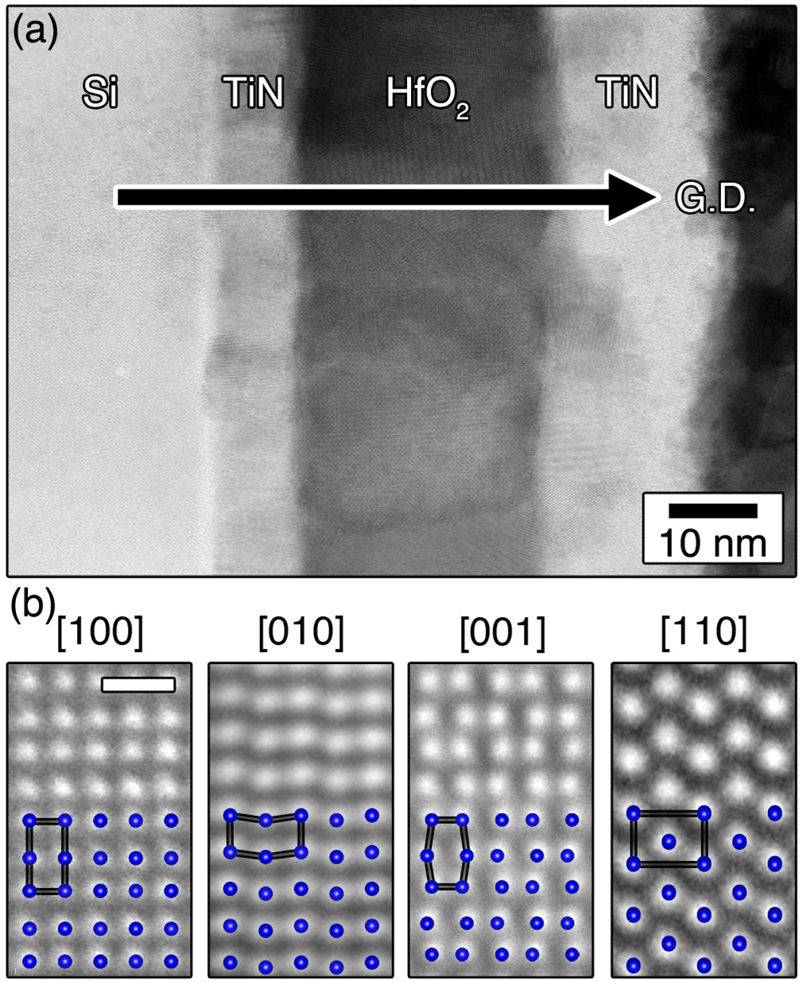

FIG. 3. (a) Bright field STEM image showing the film microstructure. The G.D. is indicated by the black arrow. (b) HAADF-STEM images acquired from four different grains superimposed with the Hf atom column arrange-ment projected along the four major zone axes, which are the same for Pca21, Pbca, and Pbcm phases. The probe semi-convergence angle was 14 mrad for ½010� and ½110� images, and 20 mrad for ½100� and ½001� images. The scale bar indicates 0.5 nm.

column positions in the STEM images.21,23The lattice con-stants measured directly in real-space are listed in Table I and are compared to literature values. The lattice parameters measured by RevSTEM are the averages from three different grains. The XRD values for Pca21 suffer from the error from peak broadening and phase mixture. Note that the reference values for other HfO2 phases determined by DFT in Ref. 15 generally agree well with the experimental values. The DFT

TABLE I. Lattice parameters for HfO2 phases from the literature compared with those measured in the current work.

values from Ref. 16 do not agree with the other sources, which may be from the algorithms selected for DFT calcula-tions. Moreover, the three structures possess a nearly identi-cal arrangement of Hf, though they vary slightly in their arrangement of oxygen. While these measurements, com-bined with arrangement of projected atom columns, rule out Pmn21 and higher symmetry phases, it is evident that the lattice constants for the orthorhombic structures are difficult to distinguish from lattice parameters alone.

To distinguish between the Pbca, Pbcm, and Pca21 phases, we turn to electron diffraction measurements. Under

|  |  |  |  |  |  |
| --- | --- | --- | --- | --- | --- |
| dynamical | conditions, | the | diffraction intensities | for | a |

non-centrosymmetric crystal no longer obey Friedel’s rule (reciprocal lattice pairs are no longer required to be of equal intensity). This benefit of electron diffraction has been used to determine the polarity at the nanoscale using CBED methods.26,27The spontaneous polarization in BaTiO3, for example, manifests as the removal of a mirror plane in the pattern.20,28In other words, by examining the symmetry of a CBED pattern, we can rapidly determine if the crystal is cen-trosymmetric or non-centrosymmetric.26,29 Furthermore, nanoscale thin films often have the potential for overlapping grains. It is therefore important to target specific regions of the film for CBED where overlap does not occur, which can be readily achieved with the PACBED technique.20,25   
 A representative HfO2 thin film region for PACBED analysis is shown in Figure 4(a). The central grain analyzed by PACBED is oriented along ½110�, as shown in the inset. It is important to note that the ½001� axis, which is polar for Pca21, is nearly parallel to the film G.D. This orientation is consistent with the observed out-of-plane ferroelectricity. Furthermore, the intensity distribution of the corresponding PACBED pattern in Figure 4(b) shows a mirror plane (solid bars) along the horizontal direction, but lacks one along the vertical direction (dashed bars), i.e., the left side of the center disc is more intense than the right half. Simulated PACBED

|  |  |  |  |  |  |  |
| --- | --- | --- | --- | --- | --- | --- |
| patterns | along | equivalent | directions | for | the | non- |

centrosymmetric Pca21, centrosymmetric Pbca, and centro-symmetric Pbcm phases are presented for comparison in Figures 4(c), 4(d), and 4(e), respectively. In contrast to the experiment, the Pbca and Pbcm PACBED patterns in Figures 4(d) and 4(e) show two perpendicular mirror planes as expected for a centrosymmetric structure. The Pca21 PACBED pattern in Figure 4(c), however, is asymmetric and in near-perfect agreement with experiment. Together with

|  |  |  |  |  |
| --- | --- | --- | --- | --- |
| a (A˚ ) | b (A˚ ) | c (A˚ ) | Source | the STEM results in Figure 3, these results confirm the pres- |

|  |  |  |  |  |
| --- | --- | --- | --- | --- |
| P21/ca | 5.1693(1) | 5.1187(4) | 5.2970(4) | XRD13 |
| b Pmn21 | 5.13 | 5.18 | 5.13 | DFT15 |
| 5.29 | 5.01 | 5.08 | DFT15 |
| Pca21 |
| 5.10 | 4.90 | 4.92 | DFT16 |
| Pbcmc | 5.23 | 5.00 | 5.05 | XRD4 |
| 5.27 | 5.05 | 5.12 | XRD13 |
| Pbcad | 5.27 | 10.03 | 5.08 | DFT15 |

ence of the Pca21 phase, which was found throughout the thin film.

In conclusion, we have quantitatively analyzed the

structural origins of ferroelectricity in Gd:HfO2 thin films using STEM imaging and diffraction. We confirm that the

source of ferroelectricity of thin-film Gd:HfO2 likely arises from the non-centrosymmetric Pca21 orthorhombic phase.

|  |  |  |  |  |
| --- | --- | --- | --- | --- |
| 5.2276(1) | 10.0172(2) | 5.0598(1) | XRD17 | Having confirmed that this phase is present, the ferroelectric |

|  |  |  |  |  |
| --- | --- | --- | --- | --- |
| Current work | 5.24(1) | 5.06(1) | 5.07(1) | RevSTEM |
| aa and b are switched to match Hf atom arrangement in Pca21.  bThe unit cell is doubled, where a ¼ a0 þ c0 and c ¼ a0 � c0, ja0j ¼ 3.42 A˚and jc0j ¼ 3.83 A˚ . cSetting Pcam is used here. | | | | |

response can thus arise from spontaneous polarization of this

structure, consistent with first-principle calculations.15

Moreover, while Gd doped HfO2 has been examined here,

we expect the structural origin observed here is common

amongst other cases of ferroelectricity reported in HfO2 and

dSetting Pcab is used here. ZrO2 based thin films.

|  |  |  |
| --- | --- | --- |
| 162905-4 | Sang et al. | Appl. Phys. Lett. 106, 162905 (2015) |

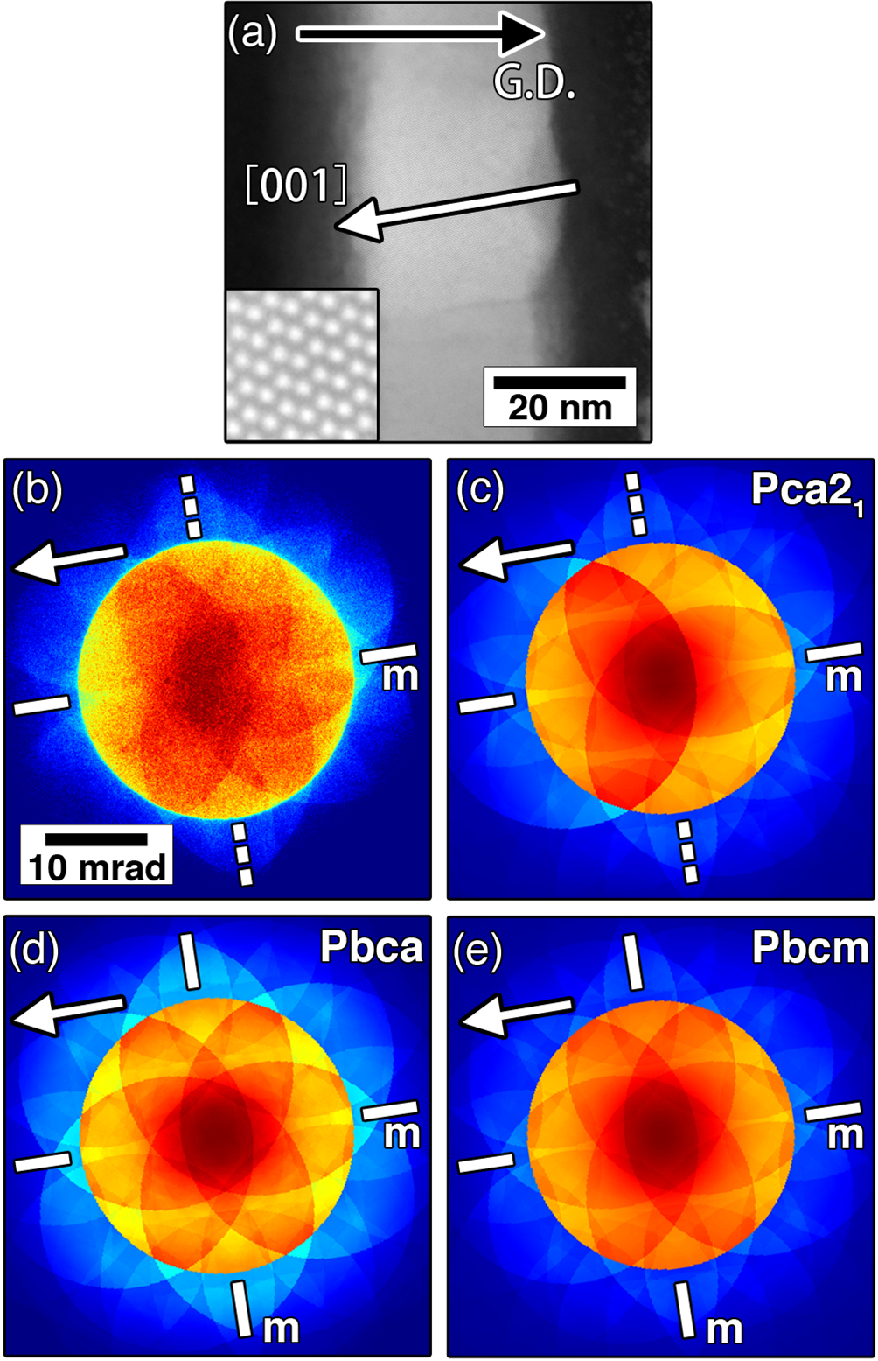

FIG. 4. (a) STEM image of the Gd:HfO2 thin film with a 2 � 2 nm2inset showing the projected structure (½110�) corresponding to the experimental PACBED pattern in (b). The sample thickness is 10 nm, as determined by PACBED. The G.D. is indicated by the black arrow. Simulated PACBED patterns for the (c) polar orthorhombic Pca21, (d) non-polar orthorhombic Pbca, and (e) non-polar orthorhombic Pbcm phases. Sample thickness was simulated to match the experiment. Solid and dashed bars indicate the pres-ence or absence of mirror symmetry, respectively.

The authors gratefully acknowledge the support from

|  |  |  |  |  |  |  |
| --- | --- | --- | --- | --- | --- | --- |
| the | National | Science | Foundation | (Award | No. | DMR- |

1350273). E.D.G. was supported by the National Science Foundation through a Graduate Research Fellowship (Award No. DGE-1252376). X.S., E.D.G., and J.M.L. acknowledge the use of the Analytical Instrumentation Facility (AIF) at North Carolina State University, which is supported by the

|  |  |  |  |  |  |  |  |
| --- | --- | --- | --- | --- | --- | --- | --- |
| State | of | North | Carolina | and | the | National | Science |

Foundation. Christoph Adelmann from Imec, Belgium is gratefully acknowledged for depositing the TiN-Gd:HfO2-TiN stacks. Tina Sturm and Almut P€ohl from Leibniz IFW Dresden, Germany are acknowledged for FIB preparation of the lamellas. Moreover, the German Research Foundation (Deutsche Forschungsgemeinschaft) is acknowledged for

funding part of this research in the frame of the “Inferox”project.

1J. M€uller, U. Schr€oder, T. S. B€oscke, I. M€uller, U. B€ottger, L. Wilde, J. Sundqvist, M. Lemberger, P. K€ucher, T. Mikolajick, and L. Frey, [J. Appl. Phys.](http://dx.doi.org/10.1063/1.3667205) 110, 114113 (2011).

2S. Mueller, J. Mueller, A. Singh, S. Riedel, J. Sundqvist, U. Schroeder, and T. Mikolajick, [Adv. Funct. Mater.](http://dx.doi.org/10.1002/adfm.201103119) 22, 2412 (2012).

3U. Schroeder, E. Yurchuk, J. M€uller, D. Martin, T. Schenk, P. Polakowski, C. Adelmann, M. I. Popovici, S. V. Kalinin, and T. Mikolajick, [Jpn. J. Appl. Phys., Part 2](http://dx.doi.org/10.7567/JJAP.53.08LE02) 53, 08LE02 (2014).

4M. Hoffmann, U. Schroeder, T. Schenk, T. Shimizu, H. Funakubo, O. Sakata, D. Pohl, M. Drescher, C. Adelmann, R. Materlik, A. Kersch, and T. Mikolajick, “Stabilizing the ferroelectric phase in doped hafnium oxide,” J. Appl. Phys. (in press).

5M. H. Park, H. J. Kim, Y. J. Kim, W. Jeon, T. Moon, and C. S. Hwang, [Phys. Status Solidi RRL](http://dx.doi.org/10.1002/pssr.201409017) 8, 532 (2014).

6S. Starschich, D. Griesche, T. Schneller, R. Waser, and U. B€ottger, [Appl. Phys. Lett.](http://dx.doi.org/10.1063/1.4879283) 104, 202903 (2014).

7P. D. Lomenzo, P. Zhao, Q. Takmeel, S. Moghaddam, T. Nishida, M. Nelson, C. M. Fancher, E. D. Grimley, X. Sang, J. M. LeBeau, and J. L. Jones, [J. Vac. Sci. Technol., B](http://dx.doi.org/10.1116/1.4873323) 32, 03D123 (2014).

8M. H. Park, H. J. Kim, Y. J. Kim, W. Lee, T. Moon, K. D. Kim, and C. S. Hwang, [Appl. Phys. Lett.](http://dx.doi.org/10.1063/1.4893376) 105, 072902 (2014).

9T. Shimizu, T. Yokouchi, T. Shiraishi, T. Oikawa, P. S. S. R. Krishnan, and H. Funakubo, [Jpn. J. Appl. Phys., Part 1](http://dx.doi.org/10.7567/JJAP.53.09PA04) 53, 09PA04 (2014).

10T. S. B€oscke, J. M€uller, D. Br€auhaus, U. Schr€oder, and U. B€ottger, [Appl.](http://dx.doi.org/10.1063/1.3634052)  [Phys. Lett.](http://dx.doi.org/10.1063/1.3634052) 99, 102903 (2011).

11T. Shimizu, T. Yokouchi, T. Oikawa, T. Shiraishi, T. Kiguchi, A. Akama, T. J. Konno, A. Gruverman, and H. Funakubo, [Appl. Phys. Lett.](http://dx.doi.org/10.1063/1.4915336) 106, 112904 (2015).

12J. M€uller, T. S. B€oscke, U. Schr€oder, S. Mueller, D. Br€auhaus, U. B€ottger, L. Frey, and T. Mikolajick, [Nano Lett.](http://dx.doi.org/10.1021/nl302049k) 12, 4318 (2012).

13D. M. Adams, S. Leonard, D. R. Russell, and R. J. Cernik, [J. Phys. Chem.](http://dx.doi.org/10.1016/0022-3697(91)90052-2)  [Solids](http://dx.doi.org/10.1016/0022-3697(91)90052-2) 52, 1181 (1991).

14R. Ruh and P. W. R. Corfield, [J. Am. Ceram. Soc.](http://dx.doi.org/10.1111/j.1151-2916.1970.tb12052.x) 53, 126 (1970).

15T. D. Huan, V. Sharma, G. A. Rossetti, and R. Ramprasad, [Phys. Rev. B](http://dx.doi.org/10.1103/PhysRevB.90.064111)  90, 064111 (2014).

16Q. Zeng, A. R. Oganov, A. O. Lyakhov, C. Xie, X. Zhang, J. Zhang, Q. Zhu, B. Wei, I. Grigorenko, L. Zhang, and L. Cheng, [Acta Crystallogr., Sect. C](http://dx.doi.org/10.1107/S2053229613027861) 70, 76 (2014).

17O. Ohtaka, T. Yamanaka, and S. Kume, [J. Ceram. Soc. Jpn.](http://dx.doi.org/10.2109/jcersj.99.826) 99, 826 (1991). 18Y. Watanabe, H. Ota, S. Migita, Y. Kamimuta, K. Iwamoto, M. Takahashi, A. Ogawa, H. Ito, T. Nabatame, and A. Toriumi, [ECS Trans.](http://dx.doi.org/10.1149/1.2779546) 11, 35 (2007).

19C. Adelmann, H. Tielens, D. Dewulf, A. Hardy, D. Pierreux, J. Swerts, E. Rosseel, X. Shi, M. K. Van Bael, J. A. Kittl, and S. Van Elshocht, [J. Electrochem. Soc.](http://dx.doi.org/10.1149/1.3301663) 157, G105 (2010).

20J. M. LeBeau, A. J. D’Alfonso, N. J. Wright, L. J. Allen, and S. Stemmer, [Appl. Phys. Lett.](http://dx.doi.org/10.1063/1.3549300) 98, 052904 (2011).

21X. Sang and J. M. LeBeau, [Ultramicroscopy](http://dx.doi.org/10.1016/j.ultramic.2013.12.004) 138, 28 (2014).

22X. Sang, A. A. Oni, and J. M. LeBeau, [Microsc. Microanal.](http://dx.doi.org/10.1017/S1431927614013506) 20, 1764 (2014). 23J. H. Dycus, J. S. Harris, X. Sang, C. M. Fancher, S. D. Findlay, A. A. Oni, T. E. Chan, C. C. Koch, J. L. Jones, L. J. Allen, D. L. Irving, and J. M. LeBeau, “Accurate nanoscale crystallography in real-space using scan-ning transmission electron microscopy,” Microsc. Microanal. (in press).

24K. Tsuda and M. Tanaka, [Acta Crystallogr., Sect. A](http://dx.doi.org/10.1107/S0108767399005401) 55, 939 (1999). 25J. M. LeBeau, S. D. Findlay, L. J. Allen, and S. Stemmer, [Ultramicroscopy](http://dx.doi.org/10.1016/j.ultramic.2009.10.001)  110, 118 (2010).

26T. Mitate, S. Mizuno, H. Takahata, R. Kakegawa, T. Matsuoka, and N. Kuwano, [Appl. Phys. Lett.](http://dx.doi.org/10.1063/1.1885174) 86, 134103 (2005).

27Y. Shi, Y. Guo, X. Wang, A. J. Princep, D. Khalyavin, P. Manuel, Y. Michiue, A. Sato, K. Tsuda, S. Yu, M. Arai, Y. Shirako, M. Akaogi, N.

Wang, K. Yamaura, and A. T. Boothroyd, [Nat. Mater.](http://dx.doi.org/10.1038/nmat3754) 12, 1024 (2013). 28Z. H. Zhang, X. Y. Qi, and X. F. Duan, [Appl. Phys. Lett.](http://dx.doi.org/10.1063/1.2405380) 89, 242905 (2006). 29P. Goodman and G. Lehmpfuhl, [Acta Crystallogr., Sect. A](http://dx.doi.org/10.1107/S0567739468000677) 24, 339 (1968).